ALUMNOS DE PRIMERO ESTOS SON LO QUE VIMOS DURANTE ESTAS DOS SEMANAS, EN LA CLASE DE INGLÉS. ESPERO QUE POR FAVOR ESTUDIEN ESTO.

ESTE TEMA ES:

DE SINGULAR A PLURAL.

SPELLING RULES

* Most nouns form their plural by adding –**s.**

One book three book**s**

* Nouns ending in –**s**, -**ss**, -**sh**, -**ch**, -**x** or –**o** take –es in the plural.

|  |  |  |
| --- | --- | --- |
| -s | Bu**s** | Bus**es** |
| -ss | dre**ss** | Dre**sses** |
| -sh | Di**sh** | Di**shes** |
| -ch | pea**ch** | pea**ches** |
| -x | bo**x** | box**es** |
| -o | potat**o** | Potat**oes** |

But some nouns ending in –**o** take only –**s**.

radio radios

piano pianos

studio studios

video videos

kilo kilos

rhino rhinos

photo photos

* Nouns ending in a **vowel** + **-y** take –s in the plural.

toy toys

boy boys

* Nouns ending in a **consonant + y** drop the –y and take –ies in the plural.

cherr**y** cherr**ies**

lad**y** lad**ies**

penn**y** penn**ies**

sp**y** sp**ies**

bab**y** bab**ies**

cit**y** cit**ies**

dais**y** dais**ies**

* Nouns ending in –**f** or –**fe** drop the –**f** or –**fe** and take –**ves** in the plural.

loa**f** loa**ves**

wi**fe** wi**ves**

hal**f** hal**ves**

kni**fe** kni**ves**

li**fe** li**ves**

el**f** el**ves**

lea**f** lea**ves**

But some nouns ending in –**f** or –**fe** take only –s.

roof roofs

giraffe giraffes

cliff cliffs

**IRREGULAR PLURALS**

Some nouns do not form their plural according to the above rules. They have either a different

form or the same form as in the singular.

These include:

|  |  |  |  |
| --- | --- | --- | --- |
| child | Children | Man | men |
| foot | Feet | Tooth | teeth |
| goose | Geese | Louse | lice |
| sheep | sheep | Ox | oxen |
| deer | Deer | Person | people |
| mouse | Mice | woman | women |
| cactus | Cacti | Focus | foci |
| fungus | fungi | nucleus | nuclei |
| syllabus | syllabi/ syllabuses | analysis | analyses |
| diagnosis | diagnoses | Oasis | oases |
| thesis | theses | Crisis | crises |
| phenomenon | Phenomena | criterion | criteria |
| datum | Data | Fish | fish |
| species | Species | aircraft | aircraft |

**PRONUNCIATION:**

The suffix of the plural form is pronounced:

* /**s**/ when the noun ends in a:

|  |  |  |
| --- | --- | --- |
| /**f**/ | roo**f** | Roofs |
| /**k**/ | duc**k** | Ducks |
| /**p**/ | lam**p** | Lamps |
| /**t**/ | skir**t** | Skirts |
| /**θ**/ | my**th** | Myths |

* /**IZ**/ when the noun ends in a:

|  |  |  |
| --- | --- | --- |
| /**s**/ | gla**ss** | Glasses |
| /**ks**/ | bo**x** | Boxes |
| /**∫**/ | di**sh** | Dishes |
| /**t∫**/ | tor**ch** | Torches |
| /**dӡ**/ | fri**dg**e | Fridges |
| /**z**/ | no**s**e | Noses |
| /**ӡ/** | mira**g**e | mirages |
|  |  |  |

* /**z**/ when the noun ends in any other sound.

girl**s** hen**s**

dog**s** bed**s**

knive**s**

**HOMEWORK:** Nouns: singular and plural

1 Complete the sentences with the plural form of the words in brackets.

A postcard from Greece.

My hotel is excellent – it was recommended by several tourist (1 company) ________________. Of course, there are (2 fly) ________________ during the day and sometimes (3 mosquito) ________________ at night, but you get used to it.

The (4 beach) ________________ are beautiful and I’ve taken lots of (5 photo) ________________ of all the old (6church) ________________ in the area.

Every day I go to the shops and buy two small (7loaf) ________________ of bread and some (8fruit) ________________ usually (9 peach) ________________ (10 orange) ________________ and (11 tomato) ________________. But I still don’t know what some of the things on the (12 shelf) ________________ are!

Yesterday, I went to the market and bought two freshly caught (13 fish) ________________ for my lunch.

There are very few (14 bus) ________________ on the island so I walk everywhere – my (15 foot) ________________ really hurt by the end of the day. I want to go into the mountains to see the (16 butterfly) ________________ there.

The (17 person) ________________are very friendly and I’ve got to know several Greek (18 family) ________________ already. The (19 child) ________________ are so sweet and the (20 man) ________________ always have interesting stories to tell about the (12 life) ________________ of their ancestors and the (22 community) ________________ they belonged over the (23 century) ________________. This is definitely one of the nicest (24 country) ________________ I’ve ever been to.

ESTE EJERCICIO.

1 ENTRAR HA ESTA PÁGINAS.

2 HAY QUE REALIZAR LOS EJERCICIOS.

3 AL TERMINAR LOS TASK, HAY QUE REALIZAR “IMPRESIÓN DE PANTALLA, CUANTO TERMINEN SU EJERCICIO”, QUIERO DECIR EL RESULTADO DE SU EVALUACIÓN.

CHECK: <http://study.com/academy/lesson/singular-plural-nouns-definitions-rules-examples.html>

EXERCIES: <http://www.englisch-hilfen.de/en/exercises_list/substantiv.htm>

TASK:

3425,____

3427,____

3429,____

3431,____

3422,____

3473,____

3415,____

3445,____

3459,____

3417,____

3467,____

3411,____

3413,____

3419,____

3455,____

3421,____

**The Verb “TO BE”**

|  |
| --- |
| AFFIRMATIVE |

|  |  |
| --- | --- |
| FULL FORM | CONTRACTED FORM |
| I am | I’m |
| You are | You’re |
| He is | He’s |
| She is | She’s |
| It is | It’s |
| We are | We’re |
| You are | You’re |
| They are | They’re |

* We usually use the **full form** of the verb **to be** in written English.

They **are** from Canada and they **are** seventeen years old.

* We use the **contracted** form of the verb **to be** in spoken English and informal written English.

A: What’s your name?

B: My name**’s** Marco and I**’m** from Italy.

NEGATIVE

|  |  |  |
| --- | --- | --- |
| FULL FORM | CONTRACTED FORM | CONTRACTED FORM |
| I am not | I’m not |  |
| You are not | You’re not | You aren’t |
| He is not | He’s not | He isn’t |
| She is not | She’s not | She isn’t |
| It is not | It’s not | It isn’t |
| We are not | We’re not | We aren’t |
| You are not | You’re not | You aren’t |
| They are not | They’re not | They aren’t |

INTERROGATIVE:

|  |  |  |
| --- | --- | --- |
| FULL FORM | Answer affirmative | Answer negative |
| Am I? | Yes, I am | No, I am not |
| Are you? | Yes, I am | No, I am not |
| Is he? | Yes, he is | No, he is not |
| Is she? | Yes, she is | No, she is not |
| Is it? | Yes, it is | No, it is not |
| Are we? | Yes, we are | No, we are not |
| Are you? | Yes, we are | No, we are not |
| Are they? | Yes, they are | No, they are not |

HOMEWORK:

<http://www.englisch-hilfen.de/en/exercises_list/hilfsverben.htm>

TASK:

1317, _________

1319, _________

1339, _________

1341, _________

1719, _________

1721, _________

1717, _________

ESTO ES LO QUE VEREMOS LA PROXIMA SEMANA.

QUESTIONS WITH **WHO, WHERE, WHEN, WHAT, HOW, HOW OLD, WHOSE**

We use

|  |  |  |
| --- | --- | --- |
| * **Who** for people. | A: **Who** are you? | B: I’m Bob |
| * **Where** for places. | A: **Where** is Michelle from? | B: She’s from France. |
| * **When** for time /dates. | A: **When** is John’s birthday? | B: It’s on June 3rd. |
| * **What** for things. | A: **What** is it? | B: It’s a book. |
| * **How** for manner. | A: **How** are you? | B: I’m fine, thanks. |
| * **How old** for age. | A: **How old** is Kate? | B: She’s twelve years old. |
| * **Whose** for possession | A: **Whose** car is this? | B: It’s Mary’s |

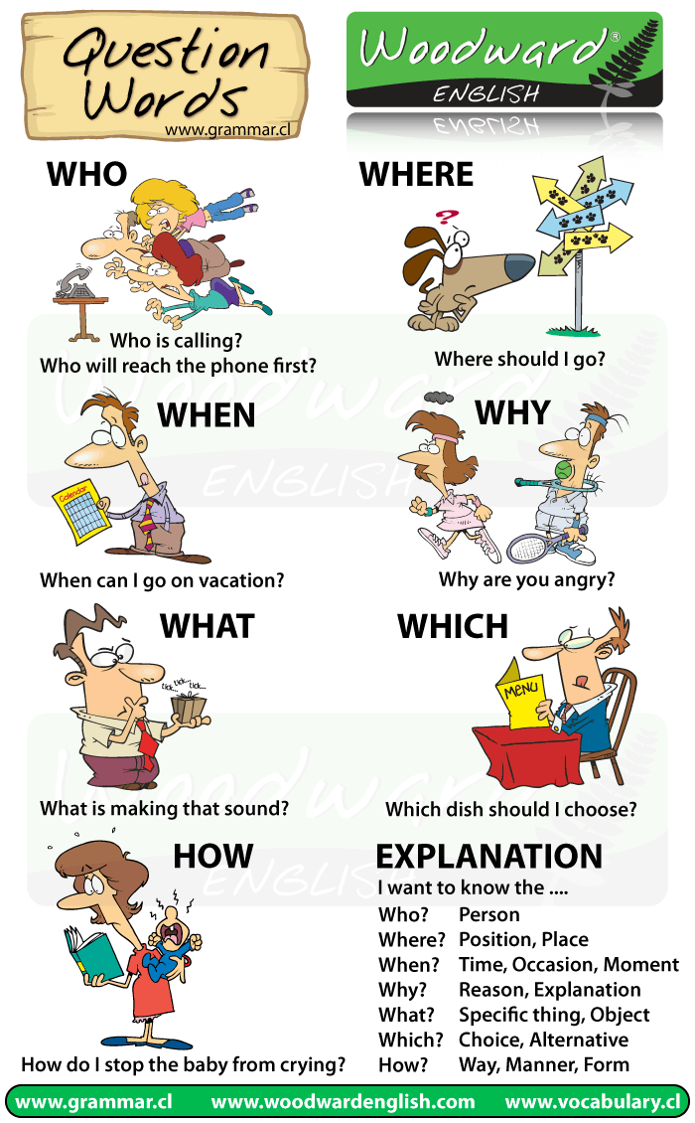

WHO

WHO is only used when referring to people (= I want to know the person)

* Who is the best football player in the world?
* Who are your best friends?
* Who is that strange guy over there?

WHERE

WHERE is used when referring to a place or location. (=I want to know the place)

* Where is the library?
* Where do you live?
* Where are my shoes?

WHEN

WHEN is used to refer to a time or an occasion. (=I want to know the time)

* When do the shops open?
* When is his birthday?
* When are we going to finish?

WHY

WHY is used to obtain an explanation or a reason. (= I want to know the reason)

* Why do we need a nanny?
* Why are they always late?
* Why does he complain all the time?
* Normally the response begins with “Because…”

WHAT

WHAT is used to refer to specific information (=I want to know the thing)

* What is your name?
* What is her favourite colour?
* What is the time?

WHICH

WHICH is used when a choice needs to be make. (= I want to know the thing between alternatives)

* Which drink did you order – the rum or the beer?
* Which day do you prefer for a meeting – today or tomorrow?
* Which is better – this one or that one?

HOW

HOW is used to describe the manner that something is done. (= I want to know the way)

* How do you cook paella?
* How does he know the answer?
* How can I learn English quickly?

With HOW there are a number of other expressions that are used in questions:

How much – refers to a quantity or a price (uncountable nouns)

* How much time do you have to finish the test?
* How much is the jacket on display in the window?
* How much money will I need?

HOW MANY –refers to a quantity (countable nouns)

* How many days are there in April?
* How many people live in this city?
* How many brothers and sister do you have?

HOW OFTEN – refers to frequency

* How often do you visit your grandmother?
* How often does she study?
* How often are you sick?

HOW FAR- refers to distance

* How far is the university from your house?
* How far is the bus stop from here?

HOMEWORK

Question page 62

<http://www.englisch-hilfen.de/en/exercises_list/fragen.htm>

task:

1351,__________

1325, __________

1381, __________

1395, __________

1355, __________

1403, __________

GOOD LUCK!

Este es un ejercicio que tienes que reolver en esta página.

HOMEWORK:

<http://www.englisch-hilfen.de/en/exercises/pronouns/personal_pronouns.htm>

TASK:

3111 _______

3113 _______

3115 _______

**“Hay tres ejercicios, por favor anota tu evaluación”**

ANIMO!

Esta es la página, del ejercicio que te cite anteriormente:

